Production Brief - Fireball! (Working Title)

[x] - Amount available/employed

# Proposal Synopsis

A 3D top down action party game for the PC, targeted towards casual gamers. The game contains various stages with different hazards and dragons as main characters. Power-ups can also be gained to enhance gameplay experience.

# Production Deliverables

A short fun playable game for casual players

* 2-4 players

# Feedback Response

* Bombs have become a power up as opposed to being the main mechanic
* The direction of the game’s atmosphere will remain cute and family-friendly

# 

# Team Members & Roles

**Members**

Designers: Glittika Gerdmanee (Nancy), Douglas Tilden (Richard)  
Artists: Tirana Kilmister, Wing Him Choi

Programmer: Finn Perry

**Roles/Responsibilities**

Glittika Gerdmanee

* Audio
* UI Design & Art (Menu & Icons)

Douglas Tilden

* Level Design (greybox & final)
* Particle System

Tirana Kilmister

* Concept Art (Character)
* Concept Art (Environment)
* Character Models
* Character Texturing
* UV Unwrapping

Wing Him Choi

* Animation
* Environment Models
* Environment Texturing
* Rigging
* UV Unwrapping

Finn Perry

* Game Mechanics
  + Character Controller
  + Critter [Enemy] Controller
  + Game Timer
  + Item Power Ups
  + Points System

# 

# Production Methodology

* Every morning - Stand up Meeting - check up on:
  + What has been completed
  + What people are currently working on
* Start of every week - check Trello
  + Have a look at our priorities
  + What has been done and what needs to be in progress
* Weekly Communication with Client
  + Communicating with the client for feedback and ensure the project is up to their standards

**Software**

* Maya
* ZBrush
* Substance Painter
* Photoshop
* Unity3D
* GitHub Desktop
* Visual Studio

**Hardware**

* Wacom Intuos Pro Medium

# Production Asset List

## Art

|  |  |  |
| --- | --- | --- |
| **Asset** | **Description** | **Polycount** |
| Bomb | Attainable Power up | 50 - 500 |
| Bomb Texture | PBR Texture | N/A |
| Bunny Critter Anim | Animation hop movement for critter | N/A |
| Bunny Critter | [Forest Arena] - main destroyable enemy | 500 - 1,000 |
| Bunny Texture | Hand-painted texture - 2 colour variations | N/A |
| Dragon Anim Attack | Animation attack action fro dragon | N/A |
| Dragon Anim Move | Animation movement for dragon | N/A |
| Dragon Char | A Playable Character | 500 - 1,000 |
| Dragon Textures [4] | Hand-painted textures - 4 colour variations | N/A |
| Environmental Textures | PBR Textures for   * Ground * Tree * Rocks | N/A |
| Rock 01-06 | Variety of rocks | 50 - 500 |
| Tree 01 | Fir tree, main tree for [Forest Arena] | 50 - 500 |
| Tree 02 | Curved tree, two main bunches of leaves | 50 - 500 |
| Tree 03 | Palm tree for [Forest Arena] and/or [Beach Arena] | 50 - 500 |

# 

# Programming

|  |  |
| --- | --- |
| **Scripts** | **Description** |
| Critter Controller | Enemy controller   * Health * Movement * Random spawn |
| Dragon Controller | Player movement controller   * Attack * Health |
| Item Power Ups | * Bomb * Drop Rate * Freeze * Flame Cone (Widen range) * Piercing Flame (Across arena) * Shot Range (Distance range) |
| Level Selection | Chooses and loads a stage |
| Multi Controller | Allow for multiple players to move individually |
| Options Menu | * Brightness * Fullscreen/Windowed * Volume (Music/SFX) |
| Timer | Countdown timer until game ends |
| Points System | * Points gained per kill * Points display upon victory screen |

# 

# UI

|  |  |
| --- | --- |
| **UI** | **Description** |
| Background UI | Scrolling background design on start up menu |
| Health Bar | Simple health display (3/3) |
| Menu Buttons | * Start Up Menu * Back buttons |
| Menu Title | Title of Game upon start up |
| Power Up Icons | Icons per power up to display when collected in game battle |

# Audio

|  |  |
| --- | --- |
| **Sounds** | **Description** |
| BGM - Arena | Music during game battle - bouncy, cute, happy |
| BGM - Main Menu | Music upon game start up |
| Bomb Explosion | After bomb power up is activated |
| Button Confirm | When an action on the menu is confirmed |
| Button Move | When player switches between buttons on menu |
| Death - Critter | When player kills a critter - rabbit squeal |
| Fireball | When a player attacks with any form of fire |
| Freeze Dispensed | When a player is frozen by Freeze Power Up |
| Power Up Collected | When power up is picked up |
| Power Up Dispensed | When power up is activated |
| Roar | When stunned, winner on victory screen - babyish, squeaky and cutesy |
| Victory Fanfare | After a round ends, plays on Victory/Score screen - upbeat, cheery and short |

# Milestone Schedule

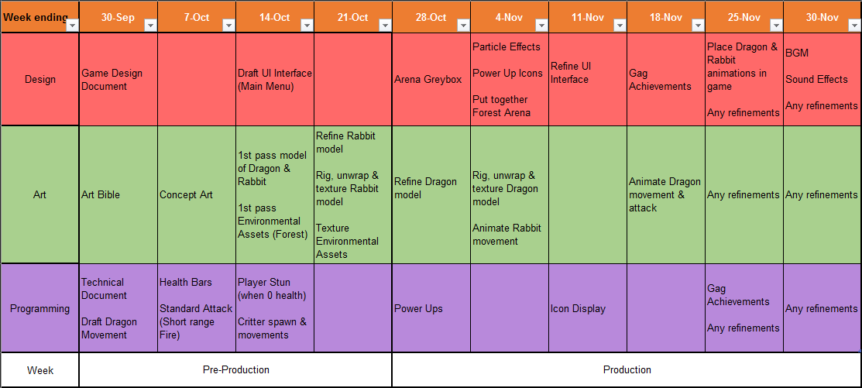

# 

# Budget

Project will approximately run for 2 months - all totals is equal to the payment of 2 months.  
However none of these payments will take place as all licensing and hardware is under student license

**Monthly Salary Total**

Entry Level Game Artist [2] - $4583.33 per person

Per month: 4583.33 x 2 = $9,166.67

Per person: 9,166.67 x 2 = $18,333.34

Entry Level Video Game Designer [2] - $5,617.25 per person

Per month: 5,617.25 x 2 = $11,234.50

Per person: 11,234.50 x 2 = $22,469

Game Programmer [1] - $8,408.70 per person

Per month: 8408.70 x 2 = $16,817.40

**Software Costs**

AutoDesk Maya License - $265 per month

Total (2 months): $530

Substance Painter Indie License - $19.90 per month

Total (2 months): $39.80

Adobe Photoshop - $44 per month

Per month: 44 x 2 = 88

Per person: 88 x 2 = 176

ZBrush (Multi-user) - $1,480 per person

Per person: $1,480 x 2 = $2960

**Hardware Costs**

Wacom Intuos Pro Medium [2] - $450 per tablet

Total: $900